Public Safety Center
Floor Area: 258,278 ft²
Occupants:
Operation Hours:
Day -
Night -

End | Days | On-Peak Consumption (kWh/period) | Off-Peak Consumption (kWh/period) | Total (Reported) | Ratio (On-Peak/Off-Peak) | Highest Demand (kW) | Load Factor (%) | On-Peak Use (kWh/day) | Off-peak Use (kWh/day) | Use (kWh/day)
3/9/2009 | 31 | 173768 | 219092 | 392860 | -21% | 619 | 85% | 5605 | 7067 | 12673
4/6/2009 | 28 | 167290 | 191236 | 358526 | -13% | 629 | 85% | 5975 | 6830 | 12805
5/6/2009 | 30 | 194085 | 210989 | 405074 | -8% | 663 | 85% | 6470 | 7033 | 13502
6/8/2009 | 33 | 195788 | 262156 | 457944 | -25% | 725 | 80% | 5933 | 7944 | 13877
7/8/2009 | 30 | 176355 | 279656 | 456011 | -37% | 750 | 84% | 5879 | 9322 | 15200
8/5/2009 | 28 | 172081 | 286017 | 458098 | -40% | 782 | 87% | 6146 | 10215 | 16361
9/4/2009 | 30 | 188123 | 309934 | 498057 | -39% | 794 | 87% | 6271 | 10331 | 16602
10/5/2009 | 31 | 166233 | 292042 | 458275 | -43% | 703 | 88% | 5362 | 9421 | 14783
11/5/2009 | 31 | 208773 | 224833 | 433606 | -7% | 664 | 88% | 6735 | 7253 | 13987
12/8/2009 | 33 | 207337 | 249474 | 456811 | -17% | 673 | 86% | 6283 | 7560 | 13843
1/8/2010 | 31 | 194773 | 212800 | 407573 | -8% | 635 | 86% | 6283 | 6865 | 13148
2/5/2010 | 28 | 178401 | 203873 | 382274 | -12% | 642 | 89% | 6371 | 7281 | 13653
3/8/2010 | 31 | 177681 | 231530 | 409211 | -23% | 627 | 88% | 5732 | 7469 | 13200

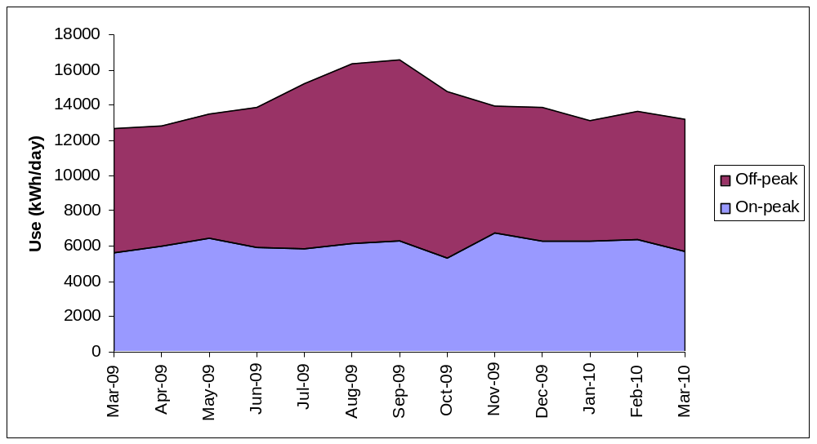

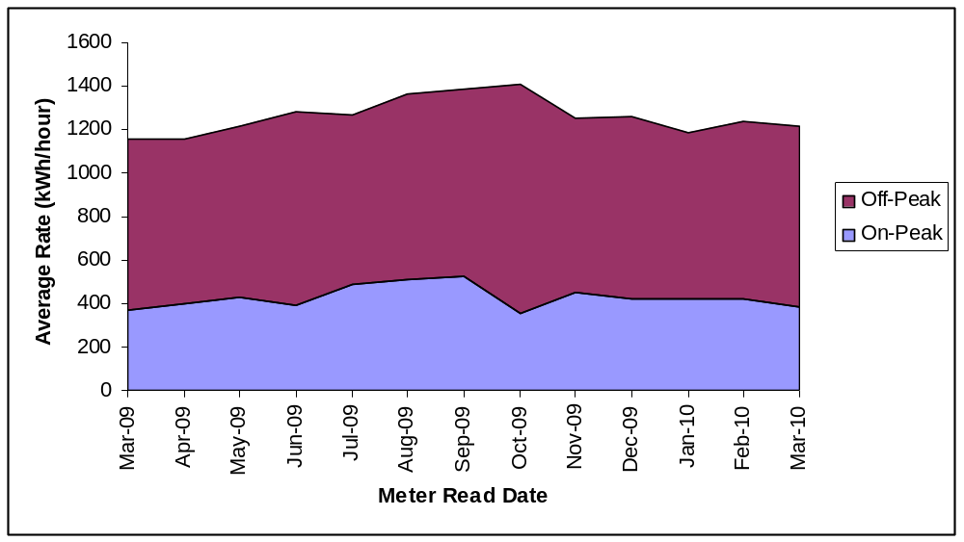
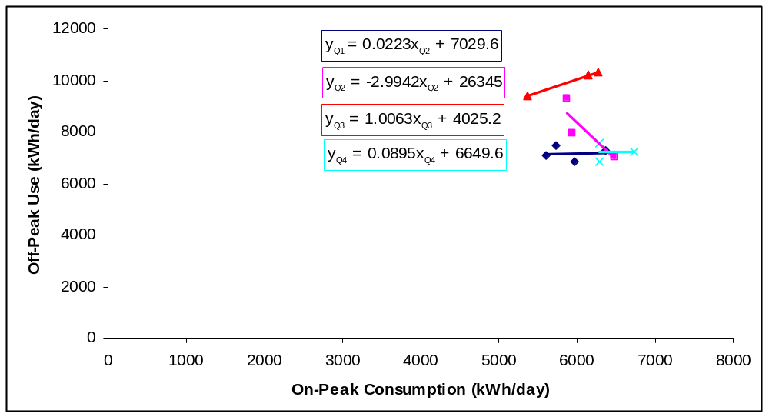

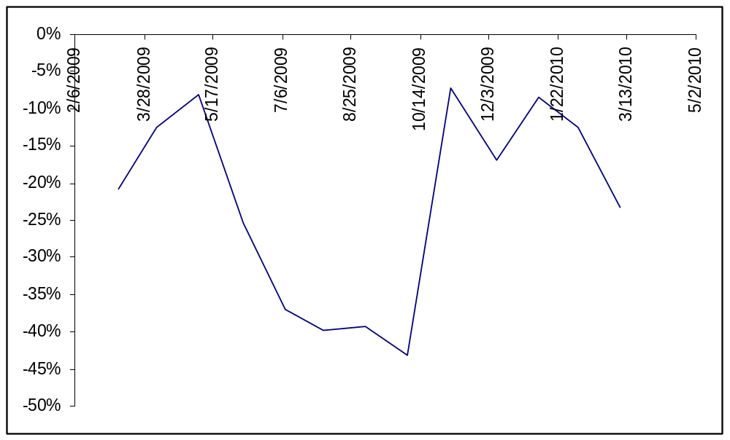

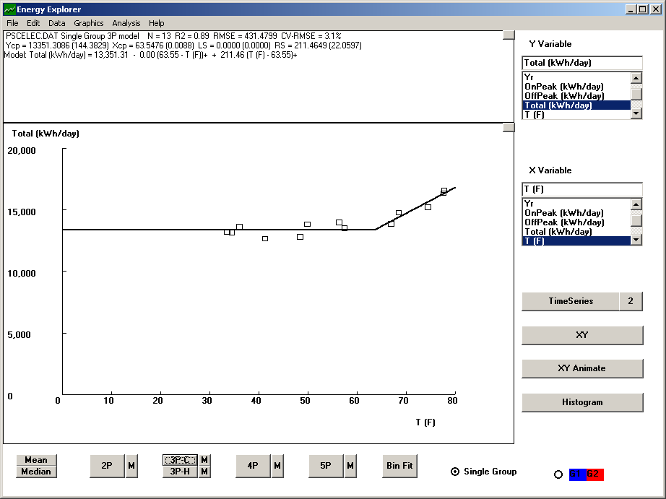

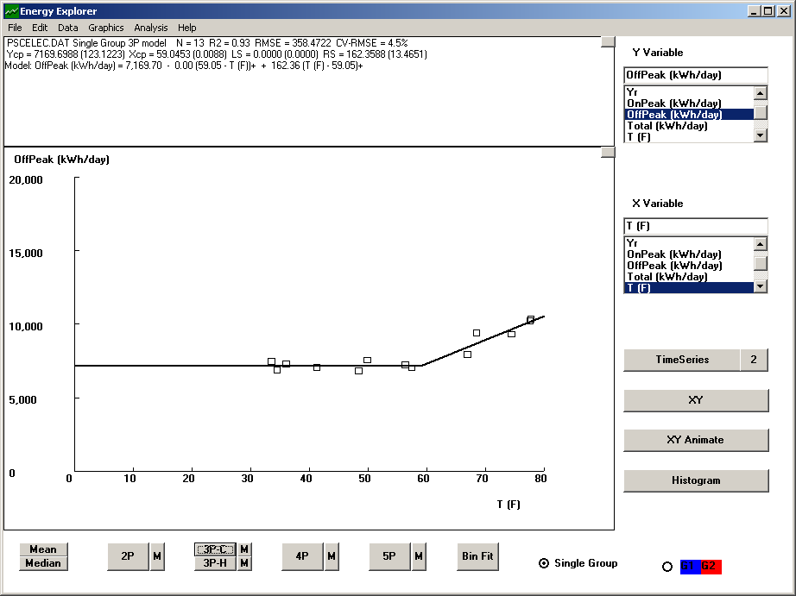

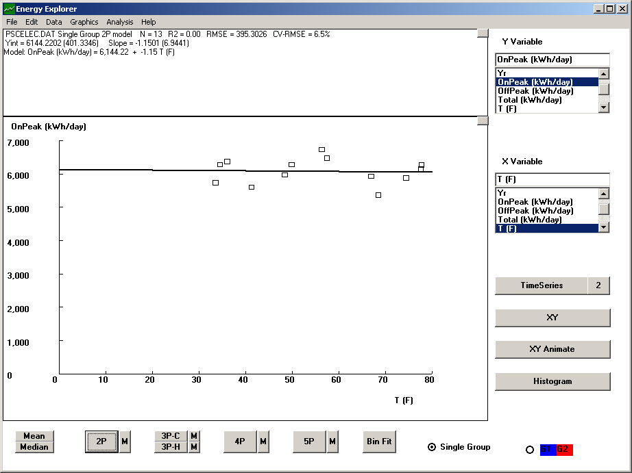

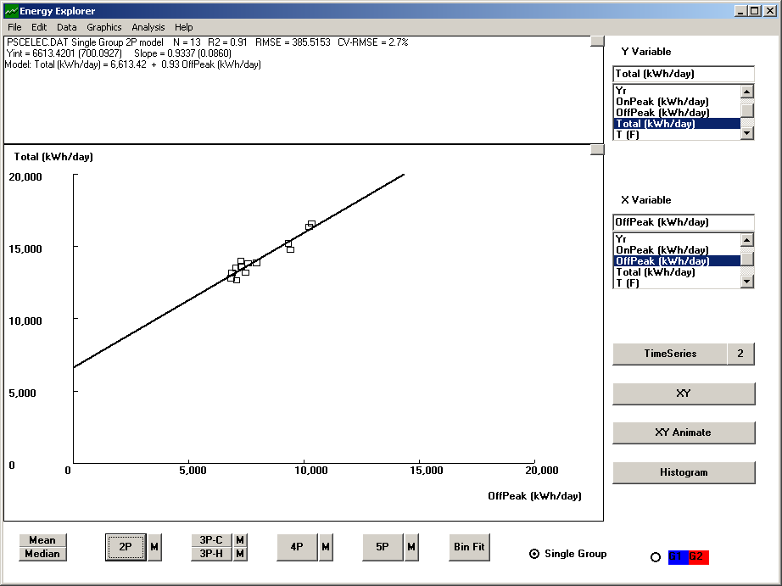
Natural Gas
